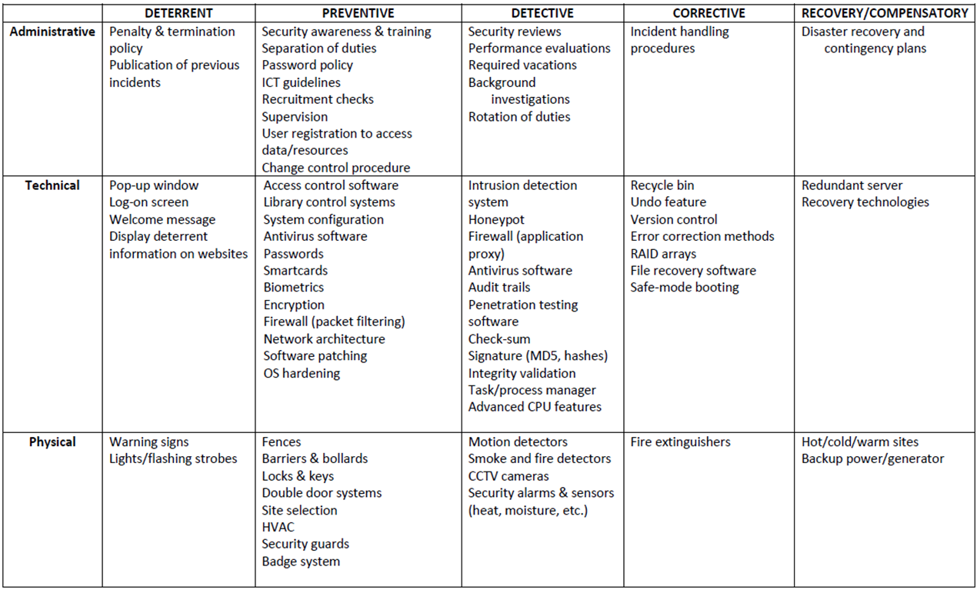

**Administrative**

**Deterrent**

* Penalty & Termination Policy
* Publication of previous incidents

**Preventive**

* Security Awareness and Training
* Separation of Duties
* Password Policies
* ICT guidelines
* Recruitment Checks
* Change control procedures

**Detective**

* **Security reviews**
* **Performance evaluations**
* **Required vacations**
* **Background investigations**
* **Rotation of duties**

**Corrective**

* Incident Handling Procedures

**Recovery/Compensatory**

* **Disaster recovery and contingency plans**

**Technical**

**Deterrent**

* **Pop-up window**
* **Log-on screen**
* **Welcome message**
* Display **deterrent**
* **information on websites**

**Preventive**

* **Access control software**
* **Library control systems**
* **System configuration**
* **Antivirus software**
* **Passwords**
* **Smartcards**
* **Biometrics**
* **Encryption**
* **FirewaII (packet filtering)**
* **Network architecture**
* **Software patching**
* **OS hardening**

**Detective**

* Intrusion detection system
* Honeypot
* tection
* FirewaII (application proxy)
* Antivirus software
* Audit trails
* Penetration testing software
* Check-sum
* Signature (MD5, hashes)
* Integrity validation
* Task/process manager
* Advanced CPU features

**Corrective**

* **RecycIe bin**
* **Undo feature**
* **Version control**
* **Error correction methods**
* **RAID arrays**
* **File recovery software**
* **Safe-mode booting**

**Recovery/Compensatory**

* Redundant server
* Recovery technologies

**Physical**

Deterrent

* **Warning signs**
* **Lights/flashing strobes**

Preventive

* **Fences**
* **Barriers & bollards**
* **Locks & keys**
* Double **door systems**
* **Site selection**
* **HVAC**
* **Security guards**
* **Badge system**

Detective

* **Motion detectors**
* **Smoke** and **fire detectors**
* **CCTV cameras**
* **Security alarms & sensors (heat, moisture, etc.)**

Corrective

* **Fire extinguishers**

Recovery/Compensatory

* **Hot/cold/warm sites**
* **Backup power/generator**